**Introduction:**

The problem of this is etude is essentially a graph problem. Where every light is a vertex and lights that also controls another light is an edge between the two vertex’s.

The aim of the problem is to determine someway that you can either turn off all the lights or as many lights as possible. Problems occur when trying to turn off all the lights when, lights and connecting switches are placed in certain ways/positions.

**Different Cases:**

For example. The lights and edges respectively; A B C -> AB BC CA, (Figure 2) this is impossible to fully solve as it is an odd number of lights that are in a loop. If we toggled B, it would also toggle C. Then if we try to toggle off the last light A, we turn back on B. This is an infinite loop that can never be fully solved. If it is an even number of lights that are in a loop then we can still solve it. A B C D -> AB BC CD DA (Figure 3), we can toggle D and then just toggle B which will fully turn off every light. If there is an odd number of lights that are in a loop. The maximum amount of lights to be solved can be expressed as, N-1. N being the amount of lights. (Figure 1)

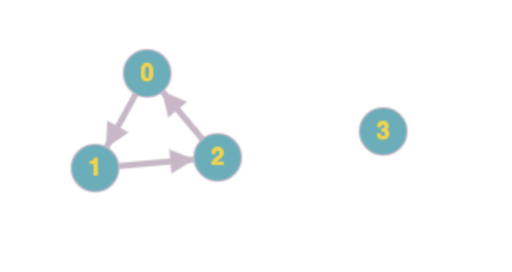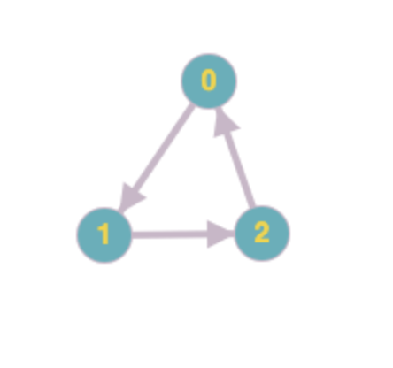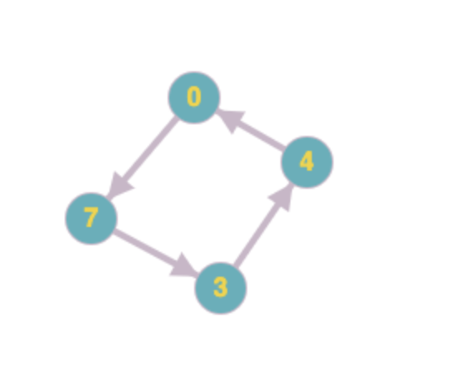

**Lights off at the start:**

If for example one light is turned off from the very beginning then the above observation is reversed (A B C->AB BC CA) . Where loops in odd amount of lights can be switched off fully and lights that are in even amount of loops can’t be switched off. This shows that what matters is the amount of lights on at the start and if they are in a loop that they are even so you can solve it. With the 3 light example there are only two lights that are on thus because there are an even amount of lights on in a loop but can be solved.

**Approach and Conclusion:**

The approach solving this was akin to brute force searching. We look to check at if there is a light that is completely on its’ own (no edges to/from it). If we find one we toggle it. If we can’t find a light that satisfies this requirement we then try a different approach. We find a node with the most edges leaving it and try to toggle it. We continue doing that until no other light satisfies this requirement. Once that part of the search is done we just look for any other light that is still on and we toggle it. At this should either be solved or the most amount of lights should be turned on. We have a maximum amount of tries before we assume that the circuit can’t be solved.